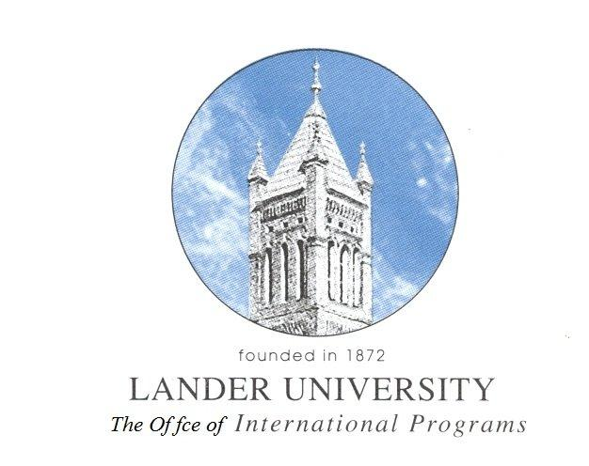
Guidelines and Protocol for Lander University
Exchange Student Program

- AREAS OF STUDY*: Lander University will accept visiting students from its sister institutions. Students will be admitted on either an F-1 VISA or a J-1 VISA (to be determined by Lander University). Lander offers degrees in the following areas of study:

Accounting | Athletic Training | Biology
Business Administration | Chemistry | Computer Information Systems
Criminal Justice | Early Childhood Education | Elementary Education
English (Creative Writing) | English Literature | Environmental Science
Finance/Economics | Genetics | Graphic Design
Health Care Management | History | Management/Marketing
Mass Communication | Mathematics | Medical Technology
Montessori Education | Music | Networking
Nursing | Physical Education | Political Science
Psychology | Public administration | Sociology
Software Development | Spanish | Special Education
Theater | Visual Arts
* Please note not all classes are available every semester. Additionally all classes offered may not be available due to capacity and pre-requisite course requirements. All students should be undergraduates and a few in a master degree in education.
- REQUIRMENTS FOR ADMISSION: Undergraduate students must be enrolled in their second year or above at their university. Additionally students must have a GPA of at least 2.5 or higher on a 4.0 scale and student must have completed either the TOEFL with a minimum score of 70 or the IELTS with a minimum score of 6.0.

- PERIOD OF STUDY: Students will be admitted for either one or two semesters; the Fall Semester is September 3, 2012 – December 14, 2012 with the Spring Semester being January 7, 2013 – April 19, 2013. After the term of study is complete student may remain in the United States for up to 30 days (J-1) and 60 days (F-1). Students should plan to arrive and depart from the Greenville/Spartanburg International Airport (GSP). Every effort will be made by the university to provide transportation to and from the airport provided the students arrive together or within a four hour window of each other, one week prior to classes beginning.

- HOUSING: Exchange Students are required to live in campus housing and participate in the university meal plan associated with the residence hall in which they are living. If a student plans to study for two semesters, from spring semester through the fall semester, and they wish to remain on campus during the summer they must be placed in a residence hall designated as a 12 month hall and pay associated additional fees.

Students will need to provide their own bedding and personal toiletries to include sheets, towels, pillow, blankets, toilet paper, soap, etc.

- FINANCES: Lander will sponsor up to five (5) Presidential Scholarships each year. This scholarship will pay approximately ½ of tuition (currently $4236 per semester). Student receiving the Presidential Scholarship are responsible for the follow semester costs (note costs are for the 2011-2012 school year – we anticipate an increase for 2012-2013; visit http://www.lander.edu/en/Business-Administration/Business-Office/Tuition-And-Fees.aspx for the most up to date fees available):
Tuition $4752
Insurance $420
Books $500 (approximate)
Room & Board $3415
Holiday Expenses $500 (approximate)
Personal Expenses $750 (approximate)
Housing Deposit $75
TOTAL $10,412

- MISCELLANEOUS: The Office of International Programs will provide an intensive orientation program for all students which will begin one week prior to the start of classes. This orientation is required and will include US customs and cultures (social and academic), campus tour, introduction to all campus student services offices, trips to local stores to purchase necessities, academic advising, class registration, and setting up a bank account

Students will be expected to follow all University, state and Federal laws throughout the duration of their stay or face deportation at the student’s expense.

